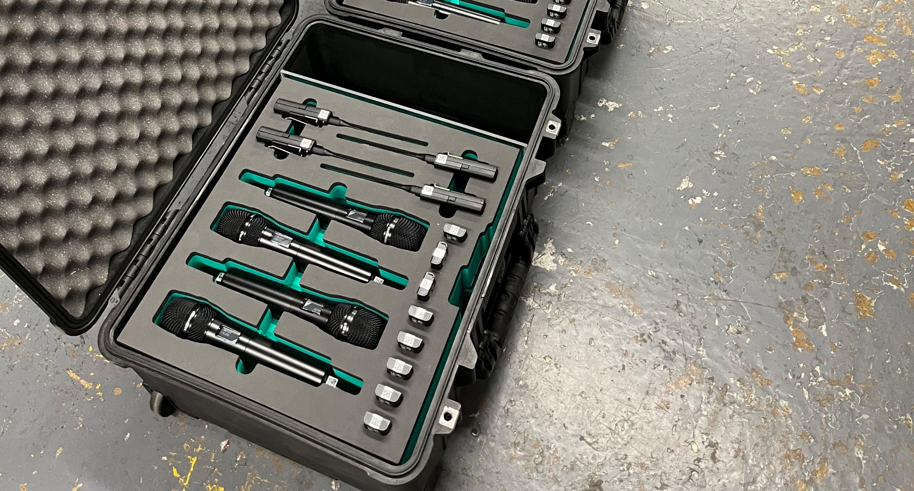
On Event Production Co. invests in Sennheiser EW-DX
UK production company strengthens its equipment lineup, sourcing 40 channels of EW-DX from trusted dealer 22live

Derby, UK, 4 December 2024 – On Event Production Co. is a Derby-based production company that focuses on making their clients’ dream events become reality. Catering for a wide variety of projects across the UK means their systems have to be flexible, scalable and reliable. When the time came to upgrade their existing Sennheiser ew 300 G3 stock, they knew the perfect solution would be the manufacturer’s EW-DX systems, and Sennheiser dealer, 22live, was happy to provide not only equipment, but also expertise.

22live launched in 2023, and thanks to the team’s solid background in live events and music, Sennheiser were early supporters and have been a key partner in helping 22live develop both sales and rental services for the pro audio market.

“Sennheiser gave us the opportunity to be a Sennheiser dealer from our inception due to our depth of knowledge and experience within pro audio and specifically live sound,” explains Alex Penn, Commercial Director of 22live. “EW-DX has been a key product for 22live due to it being brand new and having an attractive feature set and price point. It really works well, especially in the corporate events space where we have been specifically focussed with EW-DX.”

 | Alex Penn, Commercial Director of 22live

On Event Production Co. have a strong relationship with 22live, who provided demos and expert advice on accessories ahead of the significant purchase of 40 channels of EW-DX. The company purchased both EW-DX handhelds and bodypacks for each channel, along with DPA headset microphones. 22live packaged the equipment into ten four-channel sets that are easily deployable and can be scaled to any size of event.

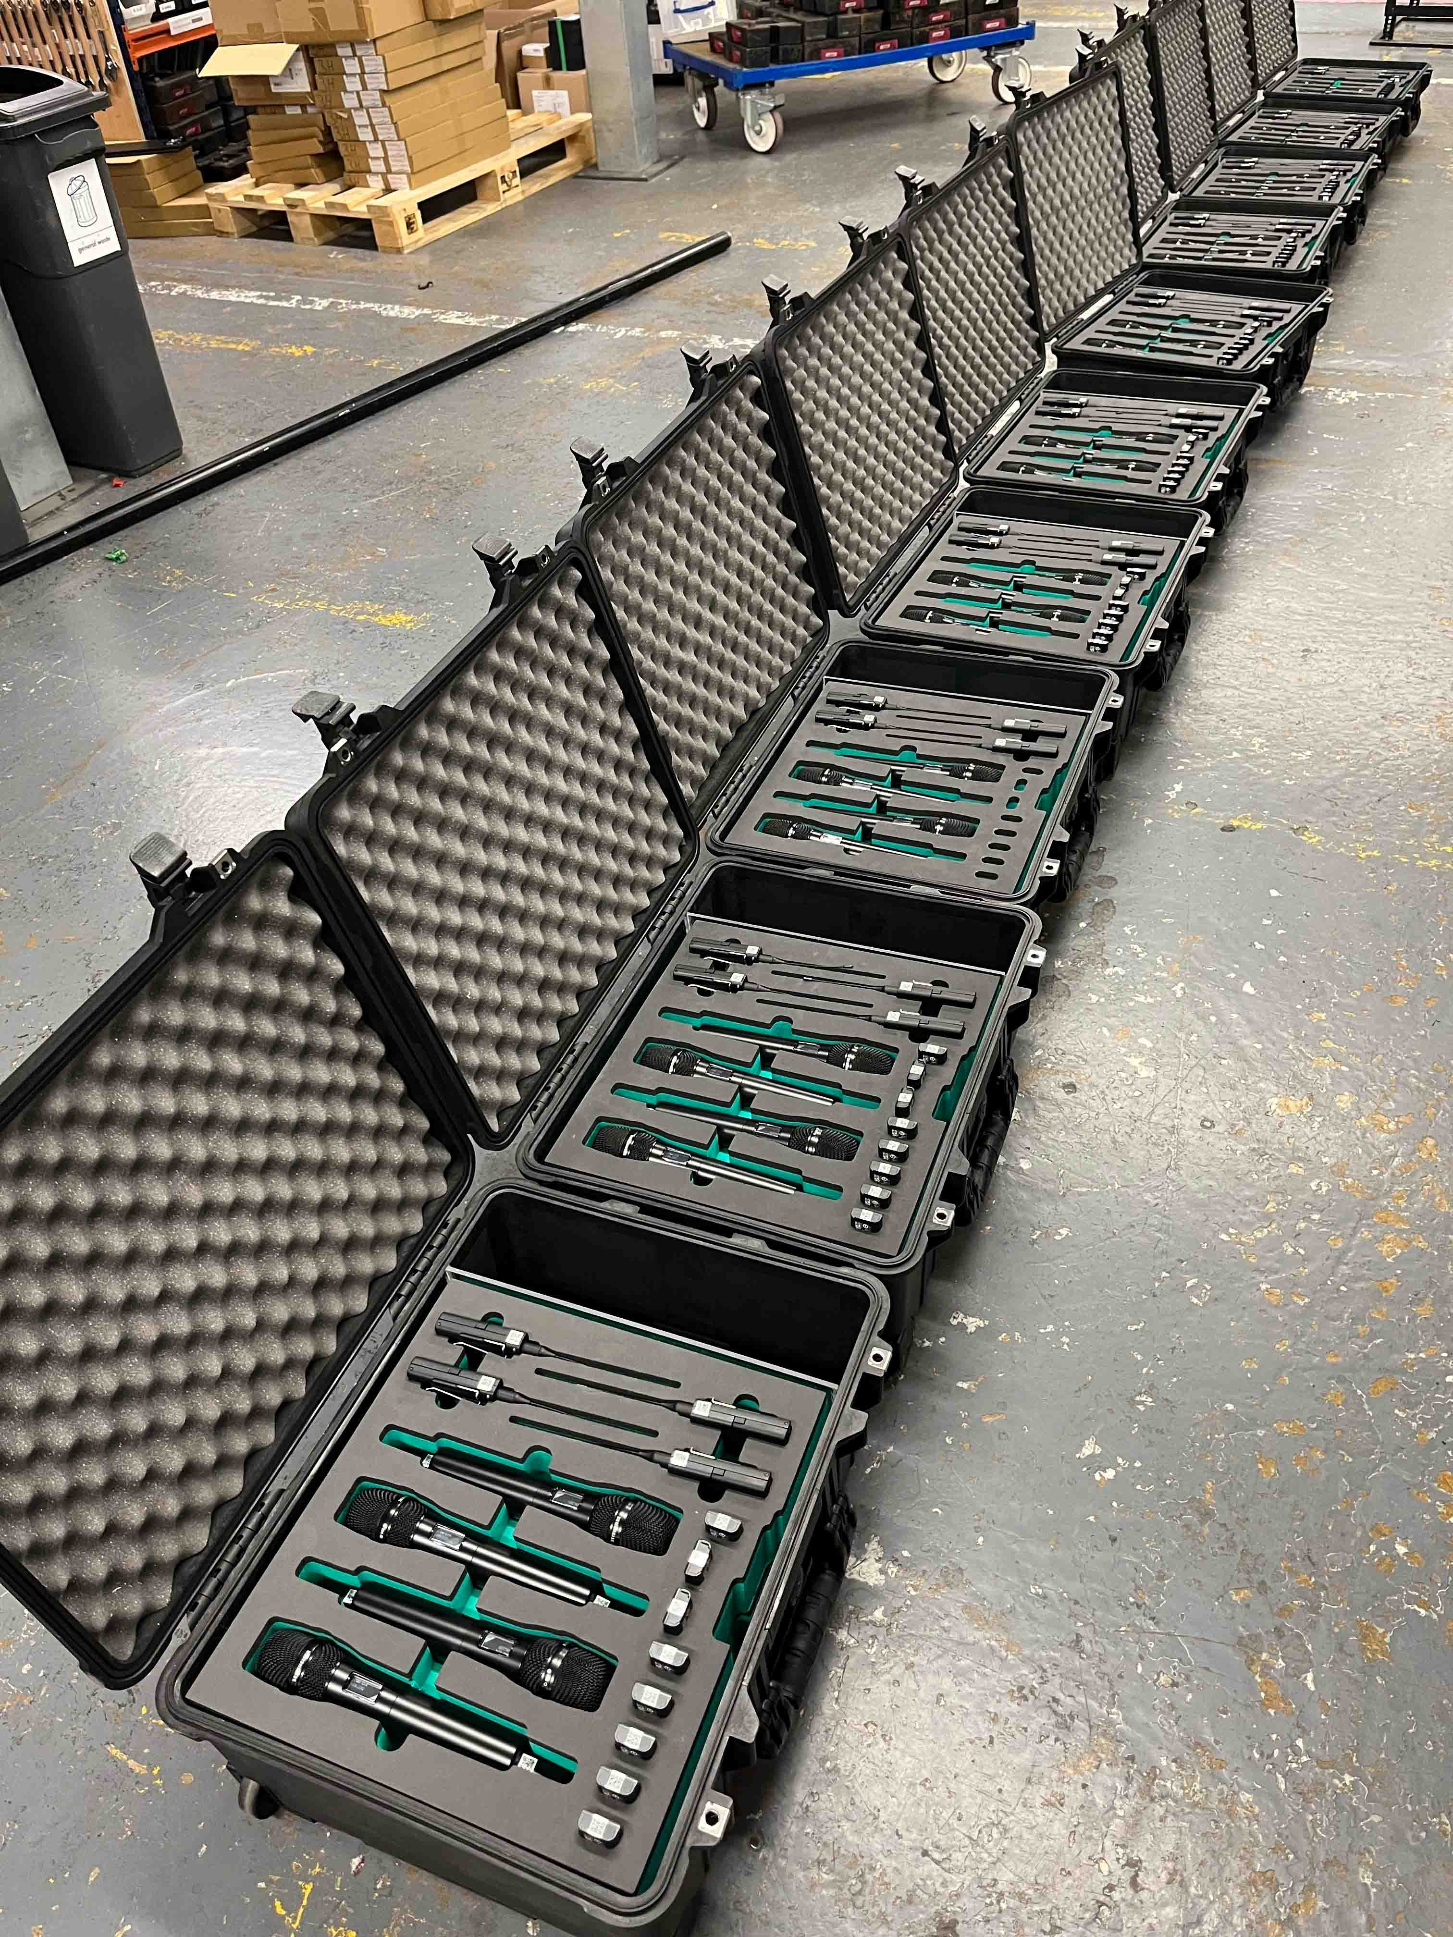 | 22live packed the EW-DX handheld and bodypack transmitters into ten convenient four channel sets complete with headset mics and batteries

“It made total sense to stay with the brand we trust,” explains Adam Dewhurst, On Event Production Co. Managing Director. “With several key clients in the financial services sector, encryption has become a crucial factor in our decision to move towards digital wireless solutions. The EW-DX offered the perfect solution, combining digital encryption, robust build quality, and integrated Dante technology.”

Adam Dewhurst, Managing Director of On Event Production Co. | 

The availability of the EW-DX EM4 DANTE quad receiver came at just the right time for On Event Production Co.’s purchase, and the company’s freelance workforce could not be happier with the equipment. Chris Thornton-Smith, Production Engineer at On Event Production Co. explains the key features that have ensured a great response from both the production company’s workforce and their freelance engineers.

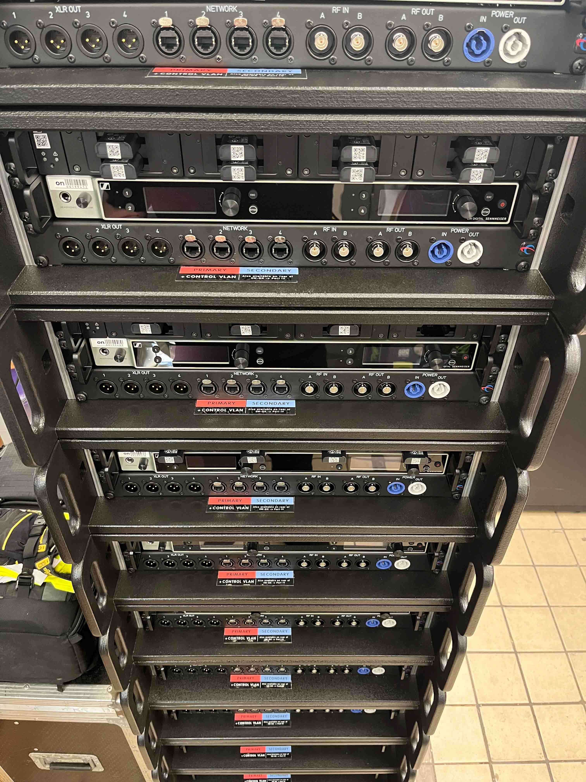 | The custom-made racks, each with an EW-DX quad receiver and L 6000 charging station

“Everyone loves how smart everything looks, how quickly the transmitters sync, and the Dante integration is key to our workflow, plus the system was a breeze to setup. All our Yamaha desks utilise Dante and it’s incredibly useful to save on analogue channels by going digital,” Thornton-Smith says. “We’ve also split them in broadcast scenarios to multiple desks with no issues to facilitate a broadcast mix of the live event - very handy! Everyone also really loves the e-ink displays on the transmitters; it saves on lots of tape, looks smarter and no more damaging the paint work!”

The extra stock in their inventory enables On Event Production Co. to rely less on sub-hires, improving efficiency and extending their prep time. The scalability of the units is also a bonus, with EW-DX receivers capable of linking four units together without additional antenna or distribution units, meaning it is very simple to adapt to any situation.

Chris Thornton-Smith, Production Engineer at On Event Production Co. | 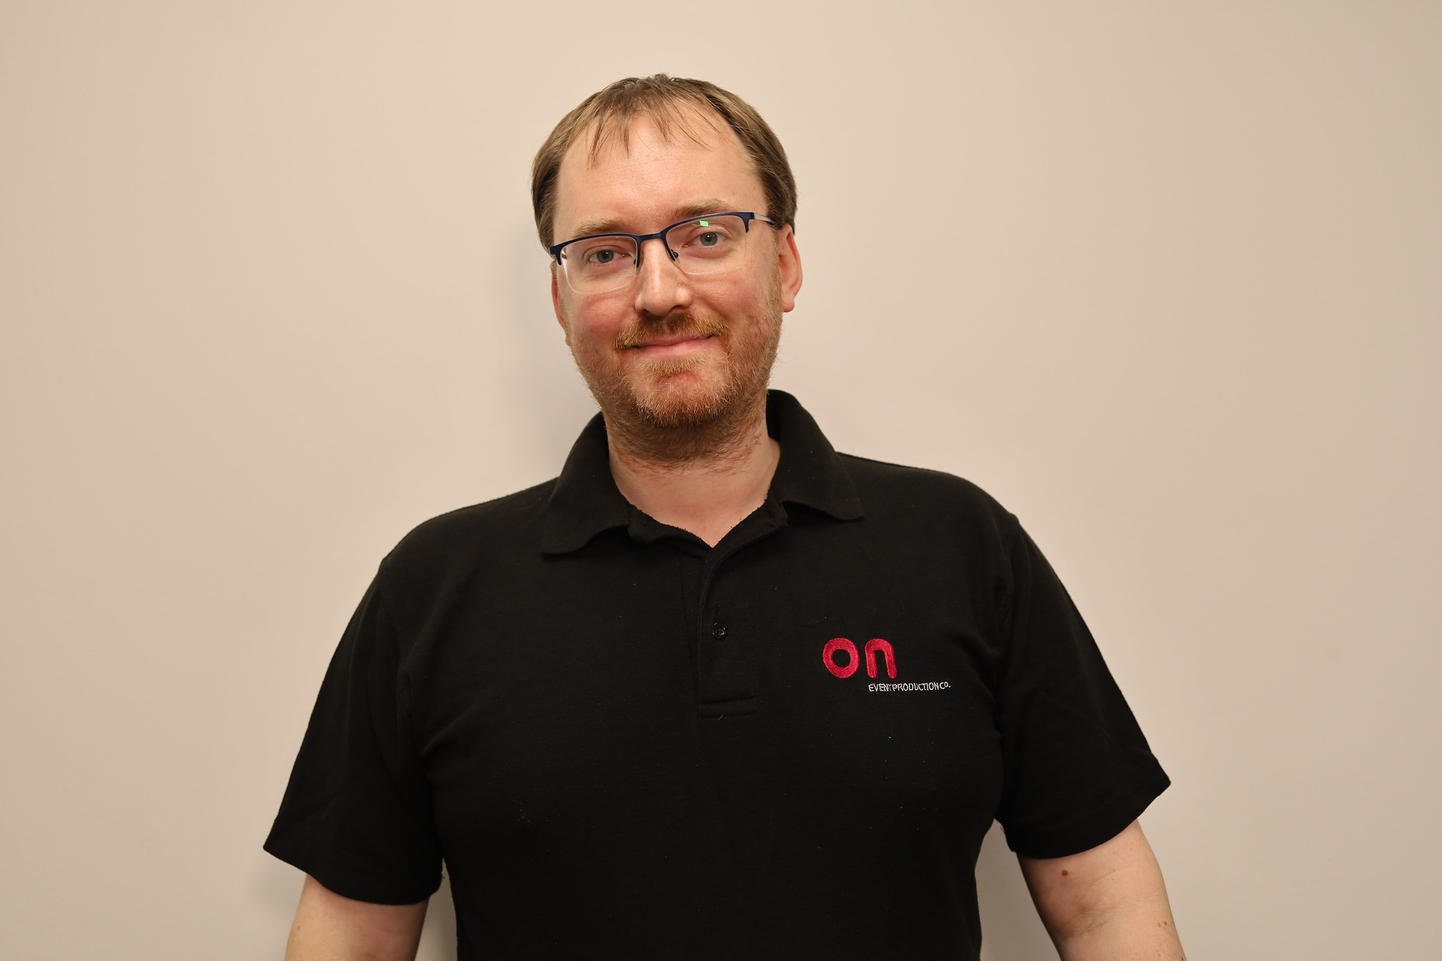

“Having 16 channels of RF from only a pair of antennas and no distro is a really nice feature,” Thornton Smith continues. “We have also packaged the systems as 3U 4-way stacker racks, meaning it’s incredibly easy to scale up, while still keeping all the RF in one case. The rechargeable batteries are great. They’ve got an incredibly long battery life and save hundreds of AA batteries being used! Our experience with 22live has been exceptional, too. Alex and the team have consistently shown responsiveness and reliability, making them a trusted partner in this upgrade.”

Seeing companies work together for a successful outcome is a real highlight for Kevin Gwyther-Brown, Business Development Manager at Sennheiser. Ensuring that good relationships have what they need to grow is an exciting part of his job and, when a business has the tools to succeed, it is good for everyone involved.

“Working with 22live to deliver a large order for Event Production Co. has been an honour,” he says. “As existing customers, it is a privilege to know that they have chosen to upgrade and modernise their inventory with Sennheiser products. Ensuring companies have all the information they need to make the right choice for their business is a key part of our work and we are delighted to see this relationship continue as the business powers forward.”

It is a sentiment that is shared by Alex Penn, as he concludes: “We recognise that our relationships are our strength, and we always strive to deliver a great experience for all those who choose to work with us. Ensuring that On Event Production Co. are able to expand their business and keep delivering fantastic events is a great outcome for 22live and we look forward to continuing to build on our relationship.”

(Ends)

The high-resolution images accompanying this media release can be downloaded here.

About the Sennheiser brand
We live and breathe audio. We are driven by the passion to create audio solutions that make a difference. Building the future of audio and bringing remarkable sound experiences to our customers – this is what the Sennheiser brand has represented for more than 75 years. While professional audio solutions such as microphones, meeting solutions, streaming technologies and monitoring systems are part of the business of Sennheiser electronic SE & Co. KG, the business with consumer devices such as headphones, soundbars and speech-enhanced hearables is operated by Sonova Holding AG under the license of Sennheiser.

www.sennheiser.com
www.sennheiser-hearing.com

Global Pro Audio Press Contact
Stephanie Schmidt
stephanie.schmidt@sennheiser.com
+49 (5130) 600 – 1275

